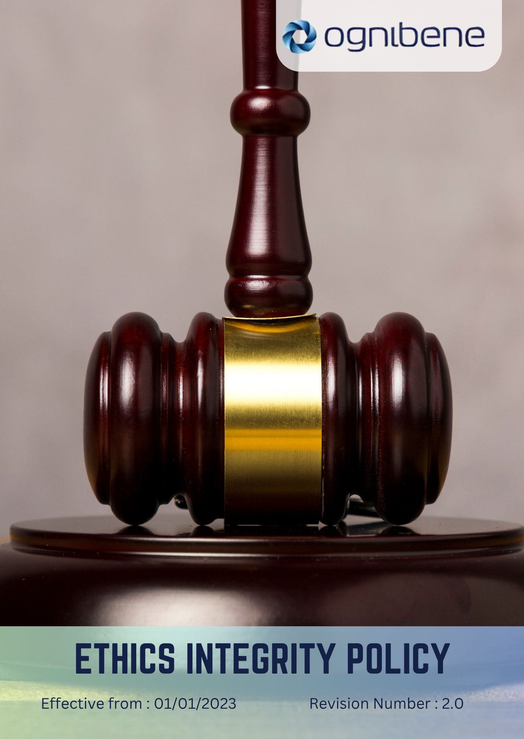

TABLE OF CONTENTS

Introduction 3
Scope 3
Policy Statement 3
Key Focus Areas 4
Do’s & Don’ts 5
SDGs Covered 7
Responsibility 7
Consequences of Violating This Policy 7
Review Mechanism 9
Revision History 9
Acknowledgement 10

Introduction
OGNIBENE INDIA PVT LTD, incorporated on February 10, 2006, is dedicated to designing and manufacturing hydraulic cylinders and hydraulic steering systems for off-highway vehicles, automotive, and marine applications. We are committed to environmental stewardship, ensuring that our operations and products contribute positively to sustainability. We are committed to conducting business with the highest ethical standards. As part of our dedication to sustainability and responsible business practices, we emphasize the importance of preventing corruption and ensuring responsible information management. This policy reflects our commitment to integrity, transparency, and accountability in all aspects of our business operations.

Scope
This policy applies to all workers, employees, directors, officers, agents, contractors, and any third parties acting on behalf of OGNIBENE INDIA PVT LTD. It covers all business activities, including procurement, sales, marketing, and any interactions with government officials, customers, suppliers, and other stakeholders. The policy is applicable globally, regardless of local business practices or cultural norms. This policy applies to below mentioned locations:

Unit 1: | Ognibene India Private Limited – Pune Plant (I)  Plot A-13 Talegaon MIDC Village Ambi Navlakh Umbhre Talegaon, Pune Maharashtra – India
Unit 2: | Ognibene India Pvt. Ltd.  Unit No. A, B-600, Plot No.8, Ishanvi Industrial & Logistics 140402 Park, Vividha Ind.Park, Chamaru, Rajpura Patiala – Punjab – India

Policy Statement
Ognibene India Pvt Ltd is committed to the highest ethical standards, prohibiting any form of corruption, bribery, or unethical behavior. We prevent conflicts of interest, fraud, and money laundering, ensuring integrity in all transactions. Our company promotes fair competition and safeguards the secure collection, processing, and storage of third-party information. By fostering transparency and accountability, we ensure ethical practices across all our business operations.

Key Focus Areas
Below are our commitments and targets towards environmental sustainability as compared to baseline year 2023.
- Corruption Prevention
- We aim for 100% compliance with anti-corruption training for all employees by the end of 2030 and will conduct annual audits in 100% of high-risk departments to identify and mitigate any corruption risks by 2030. We aim to conduct risk assessments at all sites and reduce corruption incidents by 100% by 2030 through enhanced monitoring and reporting systems.
- Conflict of Interest Management
- All employees will be required to disclose any potential conflicts of interest annually, with the goal of achieving 100% compliance by 2030 and ensuring zero unresolved conflict of interest cases through prompt and effective resolution. We aim for 100% of employees to complete conflict of interest training by 2030, ensuring timely resolution of all reported conflicts.
- Fraud Prevention
- We maintain zero fraud incidents by 2030 and We aim for 100% of finance and procurement employees to complete specialized fraud prevention training annually by 2030. We Maintain zero fraud incidents by 2030, implementing quarterly fraud monitoring reports across all departments.
- Money Laundering Prevention
- We will maintain 100% compliance with anti-money laundering (AML) regulations through comprehensive training for all relevant employees by 2030 and conduct due diligence checks on 100% of new suppliers and partners to ensure compliance with AML laws by 2030 and 100% of relevant employees to receive annual AML refresher training.
- Fair Competition
- By 2030, we aim to ensure that 100% of business agreements comply with fair competition regulations through annual competition law audits. We aim for 100% of commercial employees to complete annual fair competition workshops by 2030, and maintain zero anti-competitive cases.
- Information Security
- We maintain 100% compliance with data protection laws by 2030 by enhancing cybersecurity measures, securing the collection, processing, and storage of third-party data, and conducting quarterly security audits with a target of zero data breaches by 2030. We aim to conduct risk assessments at all sites and reduce data breaches by 95% by 2030, while 100% of employees complete cybersecurity awareness training.
- Anti-Bribery Practices
- Ognibene India will uphold a zero-tolerance policy for bribery, ensuring that 100% of employees are trained on anti-bribery policies by the end of 2030, with annual reviews of business practices to ensure compliance with anti-bribery regulations.
- Ethical Supplier Engagement
- We aim to assess 100% of suppliers for ethical business practices by 2030 through annual evaluations and implement a supplier code of conduct to ensure alignment with the company’s ethics policies.
- Community engagement
- Ognibene India committed to engaging with and supporting the communities in which we operate, we aim for 60% increase in community engagement initiatives by 2030, including 100 volunteer hours annually and 2 supported projects per year.

Do’s & Don’ts
To ensure ethical governance and integrity across all levels of the organization, the following guidelines define acceptable and unacceptable behaviors for employees, managers, directors, contractors, and external stakeholders of Ognibene India Pvt. Ltd.
- Anti-Corruption and Fraud Prevention
✅ Do’s
- Report any suspicious activities, unethical conduct, or bribery attempts to the Compliance Officer immediately.
- Maintain clear, complete, and transparent records of all business and financial transactions.
- Adhere to all anti-corruption and fraud prevention training and compliance requirements.
- Politely refuse any gifts, cash, or favors that may influence business judgment or decision-making.
❌ Don’ts
- Do not offer, solicit, or accept bribes, kickbacks, or any form of improper advantage.
- Do not falsify, conceal, or manipulate financial or operational records.
- Do not engage in fraudulent business activities or misrepresentation.
- Do not ignore or conceal any known or suspected corruption or fraud risks.
- Conflict of Interest Management
✅ Do’s
- Disclose promptly any personal, family, or financial interests that could influence professional decisions.
- Seek written approval before engaging in any external business activity related to Ognibene India’s operations.
- Follow established company procedures for reporting and resolving conflicts of interest.
❌ Don’ts
- Do not participate in decisions that personally benefit you or a related party.
- Do not engage in business with direct competitors or vendors without formal authorization.
- Do not use company resources or information for personal benefit.
- Money Laundering Prevention
✅ Do’s
- Report any suspicious or unusual transactions to the Compliance or Finance Department.
- Conduct due diligence and background checks before engaging with new clients, partners, or suppliers.
- Maintain accurate and traceable financial records for every transaction.
❌ Don’ts
- Do not approve or execute transactions without a clear business rationale.
- Do not ignore warning signs of potential money laundering activities.
- Do not structure transactions to avoid legal or regulatory reporting obligations.
- Fair Competition and Anti-Competitive Practice Avoidance
✅ Do’s
- Compete fairly and ethically in all business activities.
- Follow all applicable fair trade, competition, and antitrust laws.
- Maintain transparency and honesty during contract negotiations and pricing discussions.
❌ Don’ts
- Do not engage in price-fixing, bid-rigging, or market allocation schemes.
- Do not exchange or discuss pricing strategies, costs, or market-sensitive data with competitors.
- Do not misuse Ognibene India’s market influence to unfairly restrict competition.
- Information Security and Data Protection
✅ Do’s
- Follow all company cybersecurity and data protection protocols.
- Use strong, unique passwords and enable multi-factor authentication where applicable.
- Report phishing attempts, data breaches, or suspicious emails immediately to the IT Department.
❌ Don’ts
- Do not share confidential or proprietary information with unauthorized individuals.
- Do not use personal devices to store or transmit company-sensitive data.
- Do not click on unknown or suspicious links from unverified sources.

SDGs Covered
OIL is committed to achieve the following Sustainable Development Goals:





Responsibility
The Compliance Manager at Ognibene India Pvt Ltd is responsible for overseeing the implementation, monitoring, and enforcement of this Ethics Policy, ensuring that all employees, contractors, suppliers, and third-party associates adhere to the defined ethical standards through regular training, internal audits, and reporting to senior management. The General Manager provides strategic oversight and ensures ethical governance across all operations, while the Compliance Manager leads execution and coordination with relevant departments. Department Heads are accountable for aligning daily operations with ethical standards, the HR Department integrates compliance principles into recruitment and performance processes, and the Finance and Procurement teams uphold financial integrity and responsible sourcing. The Information Security Officer safeguards company and stakeholder data in line with legal requirements, and all employees share collective responsibility for maintaining integrity, promptly reporting violations, and fostering a culture of transparency, accountability, and ethical business conduct.

Consequences of Violating This Policy
At Ognibene India Pvt Ltd, adherence to our Ethics Integrity Policy is critical to maintaining the company's reputation, operational integrity, and legal compliance. Any violation of this policy, whether intentional or accidental, will result in strict consequences to ensure the company's commitment to ethical standards and regulatory compliance is upheld.

- Disciplinary Actions:
Violations of this policy by employees, contractors, or third parties acting on behalf of Ognibene India will lead to disciplinary measures. Depending on the severity of the breach, actions may include:
- Formal warnings or reprimands
- Mandatory retraining on ethical practices
- Suspension from duties, pending investigation
- Termination of employment or contracts

- Legal and Financial Consequences:
Certain violations, such as bribery, fraud, or failure to comply with anti-money laundering laws, may result in legal action. Individuals involved in such activities may face:
- Fines or penalties imposed by regulatory bodies
- Criminal prosecution under relevant laws, potentially leading to imprisonment
- Liability for damages, fines, or losses incurred by the company due to unethical actions

- Impact on Career and Reputation:
Employees who breach this policy may experience long-term damage to their professional careers. This could include:
- Loss of future career opportunities within Ognibene India or within the broader industry
- Damage to personal and professional reputation due to public legal proceedings or internal reporting

- Contract Termination for Third Parties:
Third parties, such as contractors or suppliers, found violating this policy will face immediate termination of their business relationship with Ognibene India Pvt Ltd. Future engagements may be prohibited, and legal action may be pursued for any harm caused by the breach.

- Zero Tolerance for Retaliation:
Ognibene India Pvt Ltd maintains a zero-tolerance policy for retaliation against individuals who report violations of the Ethics Integrity Policy. Any form of retaliation will be met with severe disciplinary measures, including potential dismissal of the retaliating party.

Review Mechanism
The Compliance Office will review this policy Bi-annually to ensure its effectiveness and relevance. This officer will assess any changes in the business environment, regulatory landscape, or internal practices that may necessitate updates to the policy. Recommendations for improvements will be made to senior management based on the findings of these reviews.

Revision History
Revision No. | Date | Description of Changes | Approved By
0.0 | 01 Jan 2023 | Initial Policy Draft | General Manager Operations
1.0 | 01 Jan 2024 | Updated Scope and add the Acknowledgement section | General Manager Operations
2.0 | 01 Jan 2025 | Updated Key Focus Areas revised with action-oriented commitments, and introduced the Do’s & Don’ts and Revision History table | General Manager Operations

Approved by: General Manager of Operations
Last Review Date: 01 JAN 2025 Next Review Date: 01 JAN 2027

Acknowledgement
I, _________________________, acknowledge that I have read, understood and agree to adhere to the company’s Ethics Integrity Policy. I recognize the importance of my role in supporting the company's commitment to ethical behaviour and committed to actively participating in the implementation of this policy. I will strive to incorporate ethically responsible practices into my daily work activities, comply with all relevant ethics regulations and company policies and support the continuous improvement of our ethical performance.

I understand that my commitment is essential to achieving the company's ethics objectives and fostering a culture of integrity and responsibility. I am dedicated to contributing to our shared vision of a trustworthy and ethical workplace and demonstrating our dedication to ethical stewardship.

Employee Name:
Employee Signature:

